TMB12A03 Active Buzzer (3v3)
https://www.alibaba.com/product-detail/1-5V-3-0V-Active-Piezo_60719806468.html?spm=a2700.7724838.2017115.2.710b21a8klQGH

Overview
Quick Details
Place of Origin:
China (Mainland)
Brand Name:
INTEC
Model Number:
BZTC002
Rated Voltage:
1.5V
Operating Voltage:
3.0V
Rated Current(MAX):
20MA
Min Sound Output at 10 cm:
80db
Resonant Frequency:
2300±300HZ
Operating Temperature:
-20~+70
Storage Temperature:
-30~+85
Housing Material:
NORYL
Weight:
2g
Packaging & Delivery
Delivery Time
3-5days
- 1.5V/3.0V Active Piezo Buzzer, TMB12A03 Buzzer, Active Piezo Buzzer
Product Description
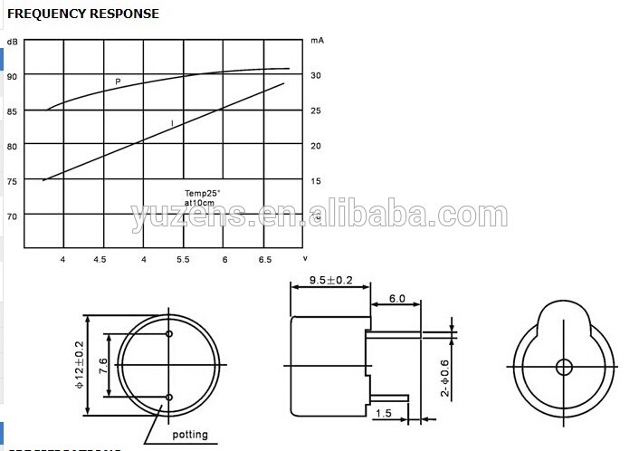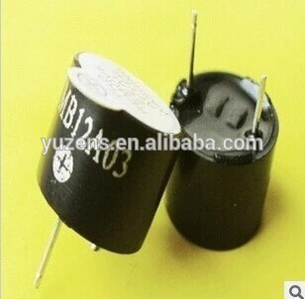
1. Rated Voltage:1.5V
2. Operating Voltage:3.0V
3. Rated Current(MAX):20MA
4. Min Sound Output at 10 cm:80db
5. Resonant Frequency: 2300±300HZ
6. Operating Temperature: -20~+70
7. Storage Temperature: -30~+85
8. Housing Material: NORYL
9. Weight: 2g

